Rulers Court Scheduler Installation Guide

Contents

Prerequisites: 2

Steps for Release Build 2

Steps for setting up scheduled tasks: 2

Active Directory Sync 4

Mail Remainder 5

Manage Engine 5

Time Attendance 6

# Prerequisites:

Dotnet core runtime for Windows x64

(<https://dotnet.microsoft.com/download/dotnet-core/thank-you/runtime-aspnetcore-2.2.3-windows-hosting-bundle-installer>)

# Steps for Release Build

This is the step for generating release build using Visual Studio 2017.

Below is the command to take release build.

*dotnet publish --configuration Release*

This needs to be executed in package manager console in Tools Menu. Release build will be generated in the path as follows: *\bin\Release\netcoreapp2.2\publish\.*

# Steps for setting up scheduled tasks:

*Please follow the below steps for setting up Task Scheduler for each of these projects. The steps will be applicable for all of the scheduler projects.*

1. Below general settings need to be followed to run the task with admin privileges

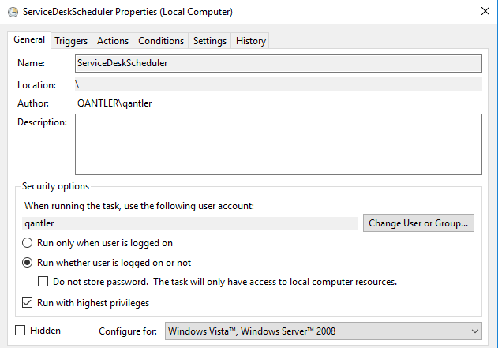

1. Scheduled time to trigger the app. The below configuration needs to be setup for every 1 hour or 5 mins - configurable.

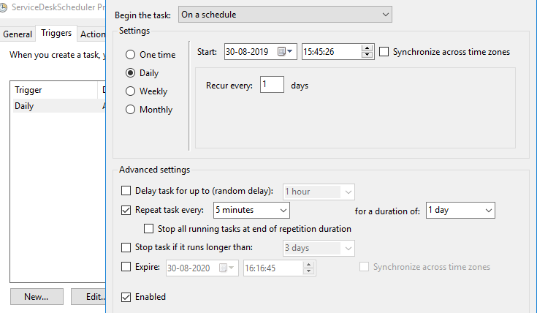

1. Below configuration is to run the app using the following arguments

* Update the release build path in the Start in field
* Update the dll name in Add Argument field
* ‘SyncManageEngine.dll’ for ManageEngine scheduler app
* ‘MailReminder.dll’ for Mail Reminder scheduler app
* ‘AdSync.dll’ for Active Directory scheduler app
* ‘TimeAttendanceService.dll’ for Time attendance scheduler app
* Update as ‘dotnet’ in Program/script field

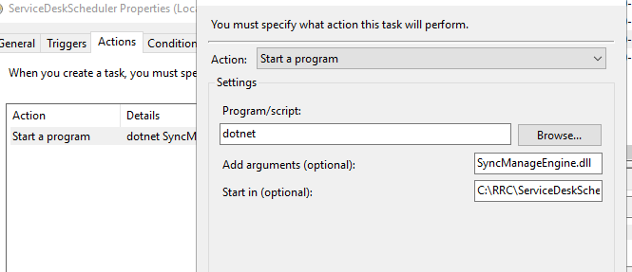

1. Below settings needs to be followed for running the instance in parallel

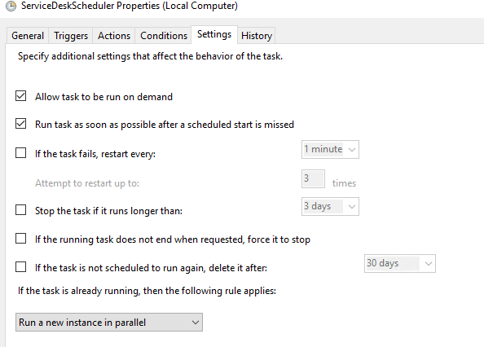

# Active Directory Sync

This scheduler is to synchronize the users from active directory to Rulers court system.

*Configuration file is in the name of ‘config.json’ in the release build path*



# Mail Remainder

This scheduler is to send reminder mails for each rulers court users intended to receive the reminder mails. For example: Meeting scheduled for an user is intended to receive reminder mails about the meeting. This is being handled using this scheduler app.

*Configuration file is in the name of ‘config.json’ in the release build path*



# Manage Engine

This scheduler is to handle the IT support ticket requests raised from Rulers Court system. This scheduler app will pick up the raised tickets and update it to the Manage engine system. In order to synchronize the system, following needs to be setup and configured.

1. Users in Manage engine should be synced with AD users. (<https://www.manageengine.com/products/service-desk-msp/help/adminguide/configurations/user-management/configuring-active-directory-authentication.html>)
2. Technician Key required for communication between the Rulers Court system and manage engine

(<https://help.servicedeskplus.com/api/rest-api.html$key>)

*Configuration file is in the name of ‘SyncManageEngine.dll.config’ in the release build path*



# Time Attendance

This scheduler is to synchronize the Leave Requests & Employee In/Out time from the external time management system. Following is required to keep the communication with the external system

1. Time attendance system API URL (For example: http://10.82.91.31:8095/api)

*Configuration file is in the name of ‘TimeAttendanceService.dll.config’ in the release build path.*

